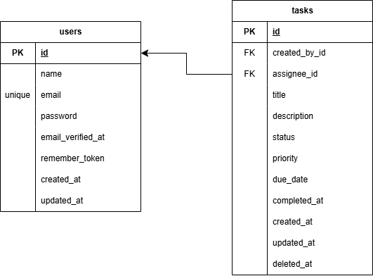ERD – Task Management Project(API)

Relationships
- users.id -> tasks.created_by_id
- A user can create many tasks.
- Each task must have one creator.

- users.id -> tasks.assignee_id
- A user can be assigned many tasks.
- Each task may have one assignee.
- Assignee is nullable, so tasks can be unassigned.

Design Explanation
The users table represents team members.
The tasks table stores the main work items. Each task has a required creator through created_by_id and an optional assignee through assignee_id. This separates who created the task from who is responsible for doing it.
Status and priority are stored as controlled string values to keep the API simple while still supporting filtering and summaries. due_date and completed_at support deadline tracking and completion history. Soft deletes are used so deleted tasks can be recoverable or auditable later.

Design Notes
- `created_by_id` is required so every task has an owner/creator.
- `assignee_id` is nullable so a task can exist before being assigned to a team member.
- `status` and `priority` are controlled string values to keep the API simple and easy to filter.
- `completed_at` is set when a task moves to `completed` and cleared when it moves back to a non-completed status.
- Soft deletes preserve deleted task records for future audit or recovery needs.
- Indexes support common API queries on status, priority, due date, assignee/status, and creator/status.

